Struture of study each topic

What I Will Add Beyond the Book
For every important concept:
✅ Real-world analogy
✅ Company examples (Netflix, Uber, Amazon, Airbnb)
✅ Interview questions
✅ Revision notes
✅ Mind maps
✅ Diagrams
✅ Industry tools
✅ Beginner explanation
✅ Engineer explanation
✅ Project connection
✅ Common mistakes
✅ Quiz

Mind map of chapter 1

Chapter 1: Data Engineering Described
│
├── 1. What is Data Engineering?
│ ├── Different definitions
│ ├── Official definition
│ └── Why it matters
│
├── 2. Data Engineering Lifecycle
│ ├── Generation
│ ├── Storage
│ ├── Ingestion
│ ├── Transformation
│ └── Serving
│
├── 3. Evolution of Data Engineer
│ ├── Data Warehouse Era
│ ├── Big Data Era
│ └── Modern Data Engineering
│
├── 4. Data Engineering vs Data Science
│
├── 5. Skills of Data Engineer
│
├── 6. Data Maturity
│ ├── Starting with Data
│ ├── Scaling with Data
│ └── Leading with Data
│
└── 7. Background and Career Path

Chapter 1: Data Engineering Described
│
├── 1. What is Data Engineering?
│ │
│ ├── Why Data Engineering exists
│ ├── Official definition
│ ├── Responsibilities of a Data Engineer
│ ├── Data → Information
│ ├── Real-world examples (Amazon, Netflix)
│ ├── Business value
│ └── Interview questions
│
├── 2. Evolution of Data Engineering
│ │
│ ├── Data Warehouse Era
│ │ ├── Why Data Warehouses were created
│ │ └── Reporting & BI
│ │
│ ├── Big Data Era
│ │ ├── Data explosion
│ │ ├── Hadoop
│ │ ├── Google papers
│ │ └── 3Vs
│ │
│ └── Modern Data Engineering
│ ├── Business-first thinking
│ ├── Automation
│ ├── Cloud
│ └── Data Lifecycle
│
├── 3. Data Engineering Lifecycle ⭐⭐⭐⭐⭐
│ │
│ ├── What is a lifecycle?
│ ├── Generation
│ ├── Storage
│ ├── Ingestion
│ ├── Transformation
│ ├── Serving
│ ├── Swiggy example
│ ├── Amazon example
│ └── Storage vs Ingestion
│
├── 4. Data Engineer vs Other Roles
│ │
│ ├── Data Engineer
│ ├── Data Analyst
│ ├── Data Scientist
│ ├── ML Engineer
│ ├── Upstream vs Downstream
│ └── Data Science Hierarchy
│
├── 5. Skills of a Data Engineer
│ │
│ ├── Data Architecture
│ ├── Data Management
│ ├── Security
│ ├── Software Engineering
│ ├── DataOps
│ ├── Orchestration
│ ├── Trade-offs
│ └── Business Thinking
│
├── 6. Data Maturity Model
│ │
│ ├── Stage 1
│ │ └── Starting with Data
│ │
│ ├── Stage 2
│ │ └── Scaling with Data
│ │
│ ├── Stage 3
│ │ └── Leading with Data
│ │
│ ├── Company examples
│ └── Business value
│
└── 7. Becoming a Data Engineer
│
├── No single career path
├── Different backgrounds
├── Core skills
├── Self-learning
├── Career roadmap
└── Industry expectations

Topic 1: What Is Data Engineering?
The authors say there are many definitions of Data Engineering, but all of them share one common idea:
A data engineer gets data, stores it, prepares it, and makes it usable for others.
Level 1 — Beginner Understanding
Now imagine a company.
The company needs:
- customer data
- sales data
- website data
- transaction data
Without data infrastructure, analysts and ML engineers cannot work.
A Data Engineer builds this infrastructure
-------------------------------------------------------------------
Real-World Example: Amazon

Open Amazon App
↓
Search iPhone
↓
Add to Cart
↓
Purchase

Every click creates data.
Customer Action
↓
Database
↓
Data Pipeline
↓
Storage
↓
Analytics Dashboard
Who builds this flow? 👉 Data Engineer.
-------------------------------------------------------------------
What Problem Does Data Engineering Solve?
Imagine a company has:
Sales Data
Customer Data
Website Data
Mobile App Data
Support Ticket Data
Everything is scattered.
Problems:
❌ Duplicate data
❌ Missing data
❌ Slow reports
❌ Wrong dashboards
❌ ML models fail
Data Engineering solves these problems.
-------------------------------------------------------------------
Developing, implementing, and maintaining systems that take raw data and produce high-quality information for analytics and machine learning.
Let's simplify it:
Raw Data
↓
Collect
↓
Store
↓
Clean
↓
Transform
↓
Useful Data
-------------------------------------------------------------------

Think Like an Engineer
Many beginners think:
Data Engineer = Writes SQL
Wrong.
A Data Engineer thinks:
Where is data created?
↓
How do I collect it?
↓
Where do I store it?
↓
How do I process it?
↓
How do I deliver it?
↓
How do I secure it?
-------------------------------------------------------------------

Industry Example: Netflix
When you watch a movie:
Every event generates data.
Netflix needs to know:
- What movies are popular?
- Which users may cancel subscriptions?
- What should be recommended?
To answer these questions
Events
↓
Collected
↓
Stored
↓
Processed
↓
Analyzed
Data Engineers build the pipeline
Data Engineering
-------------------------------------------------------------------
Purpose:
Convert raw data into useful data
Main Work:
1. Collect data
2. Store data
3. Process data
4. Deliver data
Customers:
- Analysts
- Data Scientists
- ML Engineers
- Business Teams
Goal:
Reliable and high-quality data
-------------------------------------------------------------------

Topic 2: Why Did Data Engineering Emerge?
Before understanding modern Data Engineering, we need to understand the problem it was created to solve.
The book explains the evolution in three stages
1980s-2000
↓
Data Warehouse Era

2000s-2010s
↓
Big Data Era

2020+
↓
Modern Data Engineering

Big Idea
Technology changed.
Data volume exploded.
The engineer's role evolved.
-------------------------------------------------------------------

Era 1: Data Warehouse Era (1980-2000)

The World Before Google
Imagine a bank in 1990.
They store:
- Customer accounts
- Transactions
- Loans
- Credit cards
Everything is inside databases.
Bank Database
↓
Reports
↓
Management Decisions
Simple.
Not much data.
No mobile apps.
No social media.
No streaming events.

What Problem Existed?
Executives wanted answers:
How much money did we make?
Which branch performs best?
Who are our top customers?
Operational databases were not designed for heavy analytics.
So companies created:
👉 Data Warehouses

What is a Data Warehouse?
Think of it as:
Factory Database
Bank Database
Sales Database
Customer Database
↓
Data Warehouse
↓
Reports
A Data Warehouse combines data from many systems into one place.
The book mentions pioneers like Bill Inmon and Ralph Kimball who helped define data warehousing concepts.

Limitation of This Era
Everything worked until data became huge.
Then the internet happened.
-------------------------------------------------------------------

Era 2: Big Data Era (2000-2015)

What Changed?
Companies like:
- Google
- Amazon
- Yahoo
started generating massive amounts of data

Example
Google Search
1 Search
10 Searches
100 Searches
1000 Searches
1 Billion Searches
Traditional databases started struggling.

New Problems
The famous 3 Vs of Big Data:
V | Meaning
Volume | Huge amount of data
Velocity | Data arrives fast
Variety | Many types of data

Google's Innovation
Google published papers about:

Google File System
Store huge amounts of data.

MapReduce
Process huge amounts of data.
These ideas changed the industry.

Yahoo and Hadoop
Yahoo engineers were inspired by Google's papers and created:
For many years:
Big Data = Hadoop

Real World Example
Imagine YouTube.
Every second:
Videos uploaded
Comments posted
Likes
Shares
Views
Millions of events.
Traditional systems struggled.
Big Data systems were built to handle this scale.

New Type of Engineer
During this era:
Software Engineer
+
Big Data Tools
=
Big Data Engineer
The book explains these engineers managed huge clusters and distributed systems.

Problem With Big Data
Big Data tools were powerful.
But they were difficult.
Companies often needed teams just to maintain Hadoop clusters.
Think:
Powerful
+
Complex
+
Expensive

Not ideal.
-------------------------------------------------------------------

Era 3: Modern Data Engineering (2020+)
Today the focus is different.
The book says engineers are moving away from managing complex infrastructure and focusing on the entire data lifecycle.
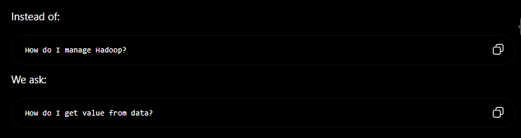

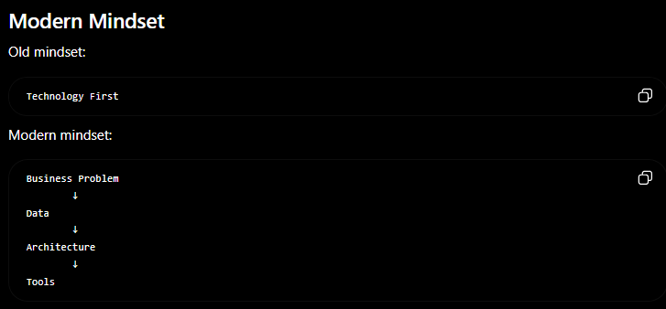

Modern Data Engineer
Today a Data Engineer focuses on:
Data Quality
Security
Governance
Architecture
Automation
DataOps
Lifecycle Management
-------------------------------------------------------------------Complete Evolution Mind Map’

2020+
│
├── Cloud
├── Data Lifecycle
├── DataOps
├── Governance
├── Security
└── Automation
-------------------------------------------------------------------Question :- what change ?

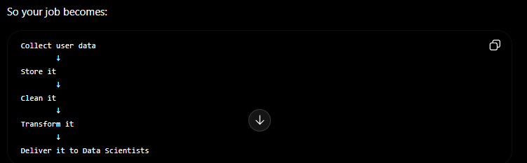

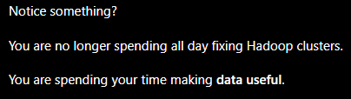

-------------------------------------------------------------------

Questions they ask:
- Is the data correct?
- Is the data secure?
- Can analysts trust it?
- Can ML engineers use it?
- Is the pipeline automated?
- Can new data sources be added easily?

The Book's Main Philosophy
This is one sentence you should remember throughout the book:
Don't focus on the technology. Focus on the data and the business problem.

Technology (Spark, Kafka, Snowflake, Databricks, etc.) is just a tool.

Business Problem
↓
Need Data
↓
Engineer Builds Pipeline
↓
Business Gets Value
------------------------------------------------------------------

Chapter 1 – Topic 3: The Data Engineering Lifecycle ⭐⭐⭐⭐⭐
This is the MOST IMPORTANT concept in the entire book.
If you understand this topic, every other chapter will make sense.
The authors even organize the whole book around this lifecycle.

What is a Lifecycle?
Let's first understand the word Lifecycle.

Real-world example: Making Tea
Water
↓
Boil Water
↓
Add Tea Leaves
↓
Add Milk
↓
Add Sugar
↓
Serve Tea

Can you serve tea before boiling water?
❌ No.
Every step happens in order.
This sequence of steps is called a lifecycle

Now Apply This to Data
Data also has a journey.
Imagine you order a pizza using the Domino's app.
The moment you click "Place Order", data begins its journey.
Customer Orders Pizza
↓
Data is Created
↓
Data is Stored
↓
Data is Moved
↓
Data is Cleaned
↓
Data is Used

This journey is called the Data Engineering Lifecycle.
-------------------------------------------------------------------

The 5 Stages
The book defines five stages:
1. Generation
↓
2. Storage
↓
3. Ingestion
↓
4. Transformation
↓
- Serving

Every modern data pipeline follows this pattern.
Let's understand each stage at a high level before studying them in depth later
-------------------------------------------------------------------.

Stage 1 — Generation

Question
Where does the data come from?
Everything starts here.
Examples:
- Customer places an order
- ATM transaction
- Instagram Like
- GPS location
- Temperature sensor
- Hospital record
These actions generate data.
-------------------------------------------------------------------

Stage 2 — Storage
Now we have data.
Question:
Where do we keep it?
Just like you save photos on your phone, companies save data.
Possible storage locations:
- Database
- Data Lake
- Data Warehouse
- Cloud Storage

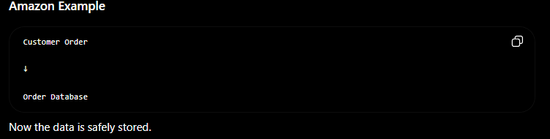

-------------------------------------------------------------------

Stage 3 — Ingestion
Now imagine this:
The order is stored in one database.
Marketing needs it.
Finance needs it.
Analytics needs it.
How do we move the data?
This movement is called Ingestion.
Order Database
↓
Analytics System

Think of ingestion as transportation.

-------------------------------------------------------------------

Stage 4 — Transformation
Raw data is usually messy.

Name : lucky

Phone : NULL

Country : india

Date : 7/1/26

Price : ₹500

Problems:
- Country uses lowercase.
- Date format is inconsistent.
- Missing phone number.
Transformation fixes these problems.
-------------------------------------------------------------------

Stage 5 — Serving
Finally:
Someone wants to use the data.
Examples:
- Dashboard
- Power BI report
- ML Model
- Mobile app
- Recommendation system
This stage is called Serving.
-------------------------------------------------------------------

Complete Real-World Example
Let's follow one Swiggy order from start to finish
You order a Burger
│
▼
1. Generation
Order is created
│
▼
2. Storage
Saved in Swiggy Database
│
▼
3. Ingestion
Copied to Analytics Platform
│
▼
4. Transformation
Calculate total sales
Remove duplicates
Standardize formats
│
▼
5. Serving
Dashboard shows:
"10,000 Burgers sold today"

Mind map
DATA ENGINEERING LIFECYCLE

Data
│
┌───────────┼───────────┐
│ │ │
Generation Storage Ingestion
│ │ │
└───────────┼───────────┘
│
Transformation
│
▼
Serving
│
┌───────────┼───────────┐
│ │ │
Dashboard Analytics ML Models

-------------------------------------------------------------------

Question :- storage and ingestion both are same if we look at it ?

Soltuion :-
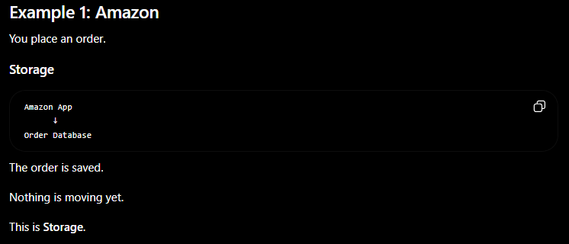

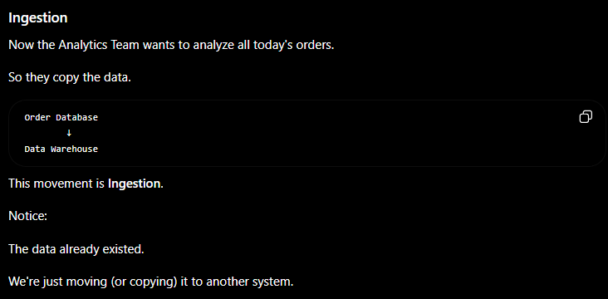
Think of it like this:
- Storage answers: "Where is the data kept?"
- Ingestion answers: "How does the data travel from one system to another?"
-------------------------------------------------------------------

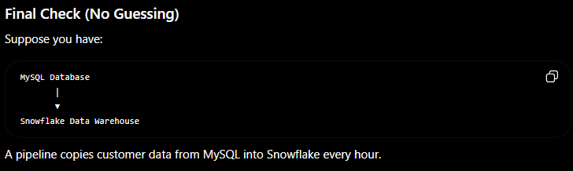

📖 Chapter 1 – Topic 4: Data Engineering vs Data Science ⭐⭐⭐⭐⭐
This is one of the most common interview questions.

A Company's Data Team
Users
│
▼
Data Engineer
│
▼
Data Analyst
│
▼
Data Scientist
│
▼
ML Engineer
│
▼
Business

Notice that the Data Engineer is upstream. The book explains that data engineering sits upstream from data science because it provides the data that data scientists use.
-------------------------------------------------------------------
Data Engineer
-------------
Collects, stores, moves, transforms, and serves data.

Data Analyst
------------
Uses data to explain what happened.

Data Scientist
--------------
Uses data to predict what will happen.

ML Engineer
-----------
Deploys ML models into production.

-------------------------------------------------------------------

Chapter 1 – Topic 5: Data Engineering Skills and Activities ⭐⭐⭐⭐⭐
Now that we know what a Data Engineer is, let's learn:
"What skills does a Data Engineer need?"
This is an interview favorite.
The book explains that a Data Engineer balances many different areas together.

The Skills Mind Map

Data Engineer
│
┌──────────────────┼──────────────────┐
│ │ │
Data Architecture Data Management Software Engineering
│ │ │
├──────────────────┼──────────────────┤
│ │ │
Security DataOps Orchestration
│
▼
Data Lifecycle

These are called the undercurrents because they affect every stage of the lifecycle
-------------------------------------------------------------------

Skill 1: Data Architecture

Question
How should we design the entire data system?
Think about building a hospital.
Before laying bricks, an architect creates a blueprint.
Without a blueprint:
- Rooms may be in the wrong place.
- Pipes may not connect.
- Electricity may fail.
The same is true for data.
Before building pipelines, someone must design:
- Where data will be stored.
- How systems connect.
- How data flows.
This is Data Architecture.
-------------------------------------------------------------------

Real-World Example
Amazon must decide:
Website
│
▼
Order Database
│
▼
Data Warehouse
│
▼
Dashboard
This overall design is the architecture.
-------------------------------------------------------------------

Skill 2: Data Management
Question:
How do we keep data organized and trustworthy?
Imagine a library.
If books are scattered randomly:
- Nobody can find anything.
A librarian organizes:
- Categories
- Labels
- Rules
A Data Engineer does something similar with data.
Examples:
- Remove duplicates
- Ensure correct names
- Define standards
- Track ownership
-------------------------------------------------------------------

Real-World Example
Imagine one system stores:
USA
Another stores:
United States
Another stores:
US
Which one is correct?
Data management creates standards so everyone uses consistent values.
-------------------------------------------------------------------

Skill 3: Security
Question:
Who is allowed to see the data?
Example:
A hospital database contains:
- Patient names
- Medical records
- Phone numbers
Should everyone be able to see it?
❌ No.
A Data Engineer helps ensure that only authorized people and systems can access sensitive data.
-------------------------------------------------------------------

Skill 4: Software Engineering
A Data Engineer also writes code.
Examples:
- Python
- SQL
- Spark
- APIs
They don't just click buttons—they build reliable software that processes data.
-------------------------------------------------------------------

Skill 5: DataOps
Think about a Formula 1 pit crew.
When a race car arrives:
- Everyone knows their job.
- Work is automated where possible.
- Mistakes are minimized.
DataOps applies the same idea to data pipelines.
Goals:
- Automation
- Reliability
- Fast deployment
- Monitoring
We'll study DataOps deeply in Chapter 2
-------------------------------------------------------------------

Skill 6: Orchestration
This sounds complicated, but the idea is simple.
Imagine cooking.
Boil Rice
↓
Cook Vegetables
↓
Make Curry
↓
Serve Food
These tasks must happen in the correct order.
Now imagine a data pipeline.
Collect Data
↓
Move Data
↓
Clean Data
↓
Generate Report
Someone has to coordinate these steps.

That coordination is called Orchestration.
Later you'll learn tools like Apache Airflow, which automate this process
-------------------------------------------------------------------

The Balancing Act
The authors explain that a Data Engineer is always balancing trade-offs.
Imagine you're building an app.
You want it to be:
- Fast ✅
- Cheap ✅
- Secure ✅
- Easy to maintain ✅
- Able to handle millions of users ✅
Can you maximize everything at once?
Usually no.
Engineers constantly balance trade-offs.
The book lists these important ones:

Cost
↔
Scalability

Simplicity
↔
Flexibility

Speed
↔
Reliability

-------------------------------------------------------------------

One Important Lesson
The book says that modern Data Engineers spend less time managing complicated infrastructure and more time choosing simple, reliable tools that deliver business value

Data Engineer Skills

1. Data Architecture
→ Design the system

2. Data Management
→ Keep data organized

3. Security
→ Protect data

4. Software Engineering
→ Build pipelines with code

5. DataOps
→ Automate and monitor pipelines

6. Orchestration
→ Run tasks in the correct order

Goal:
Deliver reliable, secure, high-quality data.
-------------------------------------------------------------------

📖 Chapter 1 – Topic 6: Data Maturity Model ⭐⭐⭐⭐⭐
The authors ask an interesting question:
Why do two companies have completely different data engineering needs?
The answer is:
Because they have different data maturity

What is "Data Maturity"?
Let's first understand the word maturity.
Think about a person
Baby
↓
Child
↓
Teenager
↓
Adult
A baby cannot drive a car.
An adult can.
Why?
Because they have grown.
This growth is called maturity.

Now Apply This to a Company
Companies also grow.

New Startup
↓
Growing Company
↓
Large Enterprise

As they grow:
- More customers
- More data
- More employees
- More systems
Their data systems also need to grow.
This growth is called Data Maturity
-------------------------------------------------------------------

The Book's Three Stages
The authors divide companies into three stages
Stage 1
Starting with Data
↓
Stage 2
Scaling with Data
↓
Stage 3
Leading with Data
-------------------------------------------------------------------

Stage 1 — Starting with Data
Imagine you and two friends create a startup.
You build a shopping website.
Customers:
10 customers
50 customers
100 customers
You store everything in one database.
You don't have:
- Data Warehouse
- Data Lake
- DataOps
- ML
- Big pipelines
The company is small.
-------------------------------------------------------------------
The book says that at this stage the Data Engineer is usually a generalist who wears many hats and focuses on getting value quickly

Stage 2 — Scaling with Data
Now your startup becomes successful.
Customers:
100
↓
10,000
↓
100,000
Problems appear.
Questions like:
- Reports are slow.
- Data comes from many systems.
- More engineers join.
- We need reliable pipelines.
The book says the focus shifts to:
- Formal data practices
- Scalable architecture
- Supporting ML
- Adopting DataOps
------------------------------------------------------------------

Stage 3 — Leading with Data
Now imagine Amazon.
Millions of users.
Everything is automated.
Customer Order
↓
Pipeline
↓
Warehouse
↓
Dashboard
↓
ML
↓
Recommendation
The company treats data as a strategic asset.
The book explains that Data Engineers now focus on automation, governance, metadata, quality, and making data available across the organization

Real Example
Netflix.
They don't manually prepare reports every day.
Everything is automated.
Engineers spend time improving the system instead of doing repetitive work.

DATA MATURITY

│
┌─────────────┼─────────────┐
│ │ │
Stage 1 Stage 2 Stage 3
Starting Scaling Leading
│ │ │
Generalist Scalable Automated
Small Team Pipelines Governance
Ad-hoc Work DataOps Self-Service
-------------------------------------------------------------------

⭐ Important Interview Question
Does a company become mature just because it has a lot of data?
❌ No.
The authors make an important point:
Data maturity is not about company age or revenue. It's about how effectively the company uses data to create value.
For example:
- A 2-year-old startup could have excellent data practices.
- A 100-year-old company could still have poor data practices
-------------------------------------------------------------------

This Is One of the Biggest Lessons in the Book
The authors repeatedly emphasize this idea:
Technology is not the goal. Business value is the goal.

A great Data Engineer asks:
"How does this pipeline help the business?"

Think Like a Senior Data Engineer
Whenever you learn a new tool, ask yourself these three questions:
- What business problem does it solve?
- Who will use the data?
- How does it create value for the company?
-------------------------------------------------------------------

📖 Chapter 1 – Topic 7: The Background and Career Path of a Data Engineer ⭐⭐⭐⭐⭐
This section answers one important question:
"How does someone become a Data Engineer?"
The authors make an important point:
There is no single path to becoming a Data Engineer. Since it's a relatively new field, people come from many different backgrounds. Universities usually don't have a standard Data Engineering degree, so continuous self-learning is essential

Skills That Every Data Engineer Needs
Regardless of your background, every Data Engineer eventually needs these skills.

Programming
│
▼
Python
SQL
Linux
Git
Cloud
Databases
Data Modeling
ETL/ELT
Data Warehouses
Distributed Systems

Business Thinking
A senior Data Engineer also understands:
- Business goals
- Product thinking
- Cost optimization
- Reliability
- Scalability
Remember what we discussed earlier:
A Data Engineer isn't just asking:
"Can I build this?"
They also ask:
"Should I build this? Does it create value?"

DATA ENGINEER

│
┌──────────────┼──────────────┐
│ │ │
Programming Databases Cloud
│ │ │
Python SQL AWS/Azure/GCP
Linux Modeling Storage
Git ETL Compute
│ │ │
└──────────────┼──────────────┘
│
Business Thinking
│
Reliable Data Systems

# | Concept | Why It Matters
1 | Data Engineering converts raw data into useful data | Foundation of the field
2 | Technology is a tool, business value is the goal | Core philosophy
3 | Data Engineer works upstream | Everyone depends on them
4 | The Data Engineering Lifecycle | Foundation of the whole book
5 | Generation → Storage → Ingestion → Transformation → Serving | Data's complete journey
6 | Modern Data Engineering focuses on business problems | Not just infrastructure
7 | Data maturity depends on how data is used, not company size | Interview favorite
8 | Data Engineers need architecture, software, security, and DataOps skills | Core competencies
9 | There is no single path into Data Engineering | Career insight
10 | Reliable data leads to better business decisions | Ultimate business goal
-------------------------------------------------------------------

